# A0: Getting Started and Setup

* Assignment A0 should be done alone.
* To begin, go to “File” and Select “Make a Copy...”
* You should seek help completing assignment A0 from the TAs at the evening lab

## Learning Objectives:

* Setup your coding environment, including your IDE, package manager, and other tools.
* Practice using all of the tools we will need in this class.
* Get to know the TAs who will be supporting your learning in this course.

## Tools

To be successful in this course, you will need to become familiar with using five primary tools: Google Drive, the course website, Moodle, the PyCharm IDE, and the Anaconda package manager. You will need to install some of these tools, and you’ll want to explore all of them. But before you dive into the deep end, let’s make sure you have the support you need to be successful in this assignment, and in this course.

## The Evening Lab

As you surely remember from the [syllabus](https://trello.com/c/pVCLItCM) that you just finished reading in preparation for [Friday’s quiz](https://trello.com/c/BXpVZMP9), you’ll know there is an evening lab in Danforth Technology Building, Room 104 that supports all of our CS students. The first part of this assignment is to visit the evening lab in the next week.

|  |  |
| --- | --- |
| **Questions and Instructions** | **Your Answers** |
| According to the syllabus, when is the evening lab open (days and times)? | 1. |
| Where is the evening lab located? | 2. |
| Visit the evening lab at your earliest convenience. Speak with any one of the many teaching assistants at the lab. They have all taken CSC 226, and are happy to help you with the course. Ask them three or more questions, of your choosing. Some suggestions (please don’t just ask the following three… it’ll become very boring for our TA’s to answer the same three questions 65+ times):   * Why did you pick CS as a major? * What was the most challenging part of CSC 226 for you? * What’s Dr. Heggen like? | Question 1:  TA’s Answer 1:  Question 2:  TA’s Answer 2:  Question 3:  TA’s Answer 3: |
| The reason you are visiting the evening lab is two-fold:   1. To enlighten you to a valuable resource for seeking out help in this course. 2. So you can get help with the installation process, which is coming in 3, 2, 1... | |

## Back to Tools

### Google Drive

You’ve made it this far, so you’re off to a good start!

We will use Google Drive significantly in this course to complete teamwork assignments collaboratively. For that, you’ll need a Google account. If you don’t have an account already, register for an account here: <https://accounts.google.com>.

One of the best features of Google Drive is its ability to allow multiple people to write in the same document at the same time. Most teamwork assignments will be accompanied with a Google Document just like this one. Since we will be exploring Google Drive in our first teamwork, we will leave much of that exploration for later. However, some things you should explore that will help you later in this course (and life, in general):

Go to [https://drive.google.com](https://drive.google.com/drive/folders/0B0J8Yj0B6KRSZjI1eVRNempyLUE?usp=sharing). Explore the interface. Note the “Install Drive for your Computer” link in the bottom left. You’ll want to consider installing this application, and putting all of your files (from now until the end of time) in the Google Drive directory. It could serve as your file backup solution until you graduate, ensuring you never lose any of your work, even if your computer crashes.

For your reference, here’s a helpful 3 minute video on why and how to do the installation: <https://www.youtube.com/watch?v=NsKnLVi2z4o>

### Trello, the Course Agenda

All course materials, including the syllabus, are posted on the course website, which can be found here: <https://trello.com/b/w7bIrLoV/>. This is the course agenda. You will find all of your due dates and expectations at this site.

Some notes about the agenda:

* The course agenda contains the **official due date** of all course materials. Sometimes, dates don’t get updated in Moodle correctly. You should ignore those errors (and let me and the TA’s know about them so we can fix them and others don’t have the same problem). Unfortunately, I have not figured out how to be a perfect human, and I still make mistakes. It is a design flaw that I am working on.
* I will update this site regularly. You should check it regularly. If a due date gets extended, it will be announced here. Although I will make regular announcements, you are responsible for knowing what is due each day.
* The calendar is a very useful way of seeing what you have due; use it!
* You can subscribe to the Trello board so you are informed of changes via email or text message. Use it!

Visit the Trello site, and answer the following two trivial questions:

|  |  |
| --- | --- |
| At what date and time is **A0: Getting Started and Setup** due? | 3.a. |
| According to the course agenda, when is quiz **Q0: The Syllabus**? | 3.b. |

### Moodle

Moodle will only be used for managing assignment submissions. You should largely disregard due dates in Moodle, as I routinely will forget to update them. **Remember, Trello has the official due dates.**

|  |  |
| --- | --- |
| Step 1: Go to https://moodle2.berea.edu | |
| Step 2: Click the itsy bitsy “Log In” button in the top right. | |
| Step 3: Log in using your Berea credentials. | |
| Step 4: Go to the “[Meta- SP17CSC226 A, B & C-Heggen](http://moodle2.berea.edu/course/view.php?id=8742)” course | |
| Step 5: Find the **A0: Getting Started and Setup** Assignment Submission page | |
| The due date and time are listed on all assignment pages. I always make assignments due at the same time (hours and minutes). At what time is **A0: Getting Started and Setup** due? | 4.a. |
| If there’s a conflict between the due date listed in Moodle and the due date listed on the course agenda from the previous section, which due date will you (and I) be held accountable to; the **Moodle due date** or the **Course Website due date**? | 4.b. |

### PyCharm IDE

To write code, typically you’ll want to use an Integrated Development Environment (IDE). For this course, we will rely on the JetBrains PyCharm Educational IDE: <https://www.jetbrains.com/pycharm-edu/download/>

Follow the installation instructions. You’ll have the option of installing Python version 2.7 or 3.5. **Install Python 3.5.**

Once you’ve installed PyCharm, play around in the interface to become more familiar with it. However, we will be exploring the interface in our first teamwork assignment on Friday, so don’t fret if it seems overwhelming at this point.

### Anaconda Package Manager

One of the benefits of Python is the many wonderful and powerful libraries. Libraries are code that has been written already, so you don’t have to reinvent it. For example, you don’t want to have to write all the code that handles every math function out there, such as square root, so you use a library called math. Some packages, like math come with Python. Others, we’ll need to get later. Instead of doing things the hard way, we’ll let a package manager handle all the hard work for us.

To download Anaconda, go here: <https://www.continuum.io/downloads>

Follow the installation instructions. All of the default settings should work.

To integrate Anaconda with PyCharm:

1. Open PyCharm. On the splash screen, click settings:

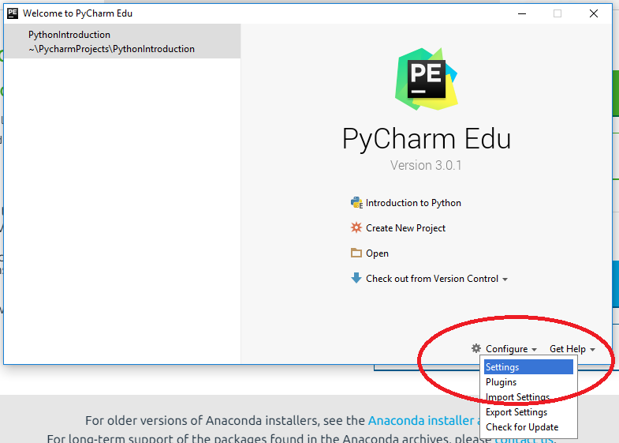

1. Under the “Project Interpreter” section, select the newly installed Anaconda version of Python:

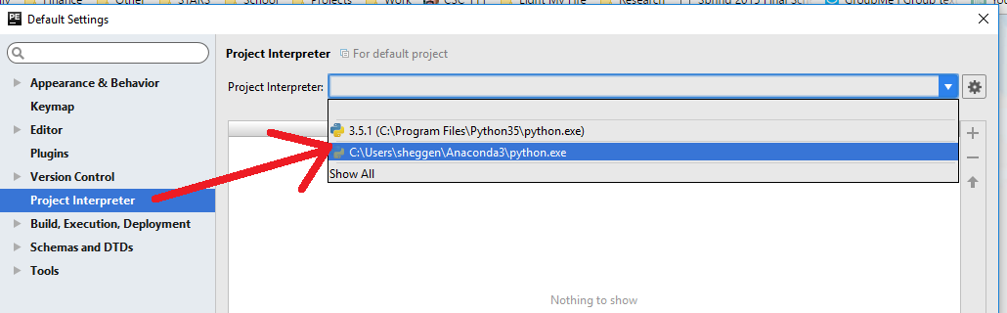

1. Click Save.

That’s all. Now when you write code that requires a non-standard library, PyCharm will know about it and automatically incorporate it into your project. More on this later...

## Did you get stuck?

Remember, the evening lab is available for you to get help on any of the steps above.

## Help Me Know You

Your last task is to help me get to learn who you are. Go to the following shared [Google Doc](https://docs.google.com/document/d/1h2SwrMuqU5qKComjscrtEf3bHAAWA0MQ3Q07mf7_anw/edit?usp=sharing), and insert your name, your section number, and a picture. Your picture should contain three things:

1. Your face, clearly visible
2. Your name on the image (Use Paint or a similar program)
3. Show you with something you are interested in (see my example).

Some more information about yourself that I’d like to know.

|  |  |
| --- | --- |
| Your Full Name: |  |
| Your Preferred Nickname: |  |
| Berea Username (e.g., heggens): |  |
| Advisor: |  |
| Intended Major(s): |  |
| Expected Graduation Date: |  |
| Gmail address: |  |
| Have you written code before, such as Python, HTML, Javascript, or any others? If so, list them here as well. | 5.a. |
| What do you hope to learn in this course? | 5.b. |
| What are your primary reasons for taking this course? | 5.c. |
| What do you like about computers? | 5.d. |
| What do you dislike about computers? | 5.e. |
| Please tell me at least one more interesting fact about yourself that you’d like me to know. | 5.f. |

## Recap

|  |  |
| --- | --- |
| A lot was done in assignment A0. Let’s see how much you remember. | |
| What are we using Google Drive for in this course? | 6.a. |
| What are we using Moodle for in this course? | 6.b. |
| Where is the official agenda, including all due dates? | 6.c. |
| What does PyCharm allow us to do? | 6.d. |
| What does Anaconda allow us to do? | 6.e. |
| What version of Python are we using? | 6.f. |

## Submission Instructions

1. Download this document as a PDF. To do this, go to File >> Download as...
2. Rename the document to***A0_username.pdf.*** Replace *username* with your Berea username. For example, my document would be named **A0_heggens.pdf.   
   NOTE:** From now on**,** incorrect filenames will automatically reduce your grade by 1 point for each assignment. Fortunately, the format is always the same no matter what the assignment.
3. Upload the document to Moodle by the due date listed on the course website: <https://trello.com/b/w7bIrLoV/>.